Name: Veera Bhosale  
PRN: 21070521093  
GenAI CA 2  
  
Q2. Generate a model in Python to represent a Housing loan scheme and create a chart to

display the Emi based on rate of interest and reducing balance for a given period. If a customer

wishes to close the loan earlier, print the interest lost distributed over the remaining no. Of

months. Assume suitable data and inputs as necessary.

Solution:

class HousingLoan:

def __init__(self, loan_amount, annual_interest_rate, loan_period_years):

self.loan_amount = loan_amount

self.annual_interest_rate = annual_interest_rate

self.loan_period_years = loan_period_years

self.loan_period_months = loan_period_years * 12

self.monthly_interest_rate = annual_interest_rate / 12 / 100

self.emi = self.calculate_emi()

* Defines a class HousingLoan which initializes with loan_amount, annual_interest_rate, and loan_period_years.
* Converts the loan period into months and calculates the monthly interest rate.
* Calls a method to calculate the Equated Monthly Installment (EMI) immediately upon initialization.

def calculate_emi(self):

r = self.monthly_interest_rate

n = self.loan_period_months

P = self.loan_amount

emi = (P * r * (1 + r)**n) / ((1 + r)**n - 1)

return emi

* This method is used to calculate the EMI using the standard EMI formula.
* It returns the EMI value based on the principal loan amount, monthly interest rate, and total number of months.

def calculate_outstanding_balance(self, months_paid):

r = self.monthly_interest_rate

n = self.loan_period_months

P = self.loan_amount

remaining_balance = (P * ((1 + r)**n - (1 + r)**months_paid)) / ((1 + r)**n - 1)

return remaining_balance

* This method will compute the outstanding loan balance after a certain number of months have been paid.
* The formula subtracts the effects of the months paid to determine how much the loan remains.

def calculate_interest_lost(self, months_paid):

total_paid = self.emi * months_paid

remaining_balance = self.calculate_outstanding_balance(months_paid)

interest_lost = self.loan_amount + (self.emi * self.loan_period_months) - (total_paid + remaining_balance)

return interest_lost / (self.loan_period_months - months_paid)

* This method calculates the interest lost if the loan is closed before the complete loan term.
* It finds how much interest is lost monthly over the remaining loan period.

def plot_emi_vs_interest(loan_amount, loan_period_years):

interest_rates = np.linspace(5, 15, 100) # Interest rates from 5% to 15%

emis = []

for rate in interest_rates:

loan = HousingLoan(loan_amount, rate, loan_period_years)

emis.append(loan.emi)

plt.figure(figsize=(10, 6))

plt.plot(interest_rates, emis, label='EMI', color='blue')

plt.xlabel('Interest Rate (%)')

plt.ylabel('EMI Amount')

plt.title('EMI Amount vs Interest Rate for Loan Period of {} Years'.format(loan_period_years))

plt.grid(True)

plt.show()

* This function generates and plots a graph showing the variation in EMI as a function of different interest rates (from 5% to 15%) for a given loan period.
* Uses numpy to generate a range of interest rates and iterates to calculate EMI for each rate, which is then plotted using matplotlib.

loan_amount = 500000 # Example loan amount

loan_period_years = 10 # Example loan period (years)

annual_interest_rate = 8 # Example interest rate

loan = HousingLoan(loan_amount, annual_interest_rate, loan_period_years)

months_paid = 5 * 12

outstanding_balance = loan.calculate_outstanding_balance(months_paid)

interest_lost = loan.calculate_interest_lost(months_paid)

print(f"EMI for loan amount {loan_amount} at {annual_interest_rate}% interest: {loan.emi:.2f}")

print(f"Outstanding balance after {months_paid} months: {outstanding_balance:.2f}")

print(f"Interest lost per month if loan is closed after {months_paid} months: {interest_lost:.2f}")

plot_emi_vs_interest(loan_amount, loan_period_years)

* **Initialize loan**: Create a loan object with specified loan amount, interest rate, and loan period.
* **Calculate EMI**: Print EMI, outstanding balance after 5 years (60 months), and interest lost if the loan is closed early.
* **Plot**: Plot EMI vs. interest rates using the plot_emi_vs_interest function.

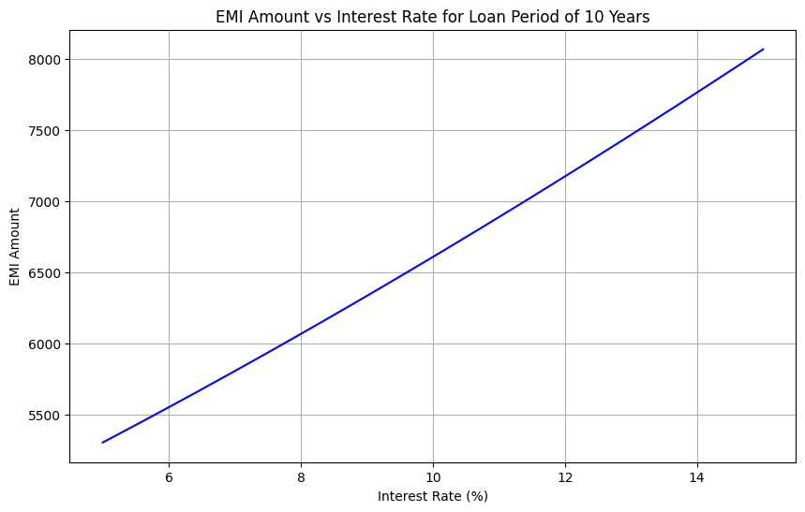]

Q:3 Generate a model for an Insurance company to hold information on the insurer's vehicle,

and create a chart of monthly, yearly, and quarterly premiums based on no. of years of insurance

where in each year, the value of the vehicle depreciates by 7%.

class VehicleInsurance:

def __init__(self, vehicle_value, initial_premium_rate, insurance_period_years):

self.vehicle_value = vehicle_value

self.initial_premium_rate = initial_premium_rate # Premium rate as a percentage of vehicle value

self.insurance_period_years = insurance_period_years

self.depreciation_rate = 0.07 # 7% depreciation per year

Initializes the VehicleInsurance class with:

* vehicle_value: initial value of the vehicle.
* initial_premium_rate: percentage of vehicle value used to calculate the insurance premium.
* insurance_period_years: number of years the policy is valid.
* depreciation_rate: set at 7% annually, to account for vehicle depreciation.

def calculate_premium(self, year):

depreciated_value = self.vehicle_value * ((1 - self.depreciation_rate) ** year)

annual_premium = depreciated_value * self.initial_premium_rate / 100

quarterly_premium = annual_premium / 4

monthly_premium = annual_premium / 12

return monthly_premium, quarterly_premium, annual_premium

Calculates the premium for a specific year:

* Depreciates the vehicle value by 7% each year.
* Uses the depreciated value to calculate annual, quarterly, and monthly premiums based on the initial premium rate.
* Returns monthly, quarterly, and annual premiums.

def calculate_premiums_over_years(self):

monthly_premiums = []

quarterly_premiums = []

annual_premiums = []

for year in range(1, self.insurance_period_years + 1):

monthly, quarterly, annual = self.calculate_premium(year)

monthly_premiums.append(monthly)

quarterly_premiums.append(quarterly)

annual_premiums.append(annual)

return monthly_premiums, quarterly_premiums, annual_premiums

Calculates premiums for every year in the insurance period:

* Iterates over each year of the policy (from year 1 to insurance_period_years).
* For each year, calls the calculate_premium method to compute the monthly, quarterly, and annual premiums.
* Stores these premiums in respective lists and returns the lists of premiums for all years.

def plot_premiums(insurance_period_years, monthly_premiums, quarterly_premiums, annual_premiums):

years = list(range(1, insurance_period_years + 1))

plt.figure(figsize=(10, 6))

plt.plot(years, monthly_premiums, label='Monthly Premium', marker='o', color='blue')

plt.plot(years, quarterly_premiums, label='Quarterly Premium', marker='o', color='green')

plt.plot(years, annual_premiums, label='Annual Premium', marker='o', color='red')

plt.xlabel('Years of Insurance')

plt.ylabel('Premium Amount (in ₹)')

plt.title('Vehicle Insurance Premiums Over Time')

plt.grid(True)

plt.legend()

plt.show()

Plots the monthly, quarterly, and annual premiums over the entire insurance period:

* The x-axis represents the number of years the insurance policy has been running.
* The y-axis shows the premium amounts.
* It plots three lines: monthly, quarterly, and annual premiums, using different colors and labels.
* The graph includes a title, grid, and legend.

vehicle_value = 1000000 # Initial value of the vehicle (₹1,000,000)

initial_premium_rate = 2 # 2% of vehicle value as the annual premium

insurance_period_years = 10 # Number of years the insurance policy will run

# Create a vehicle insurance object

insurance = VehicleInsurance(vehicle_value, initial_premium_rate, insurance_period_years)

# Calculate the premiums over the insurance period

monthly_premiums, quarterly_premiums, annual_premiums = insurance.calculate_premiums_over_years()

# Plot the premiums

plot_premiums(insurance_period_years, monthly_premiums, quarterly_premiums, annual_premiums)

* Defines the vehicle_value, initial_premium_rate, and insurance_period_years for the insurance policy.
* Creates a VehicleInsurance object using the defined values.
* Calls the calculate_premiums_over_years method to get lists of monthly, quarterly, and annual premiums over the policy period.
* Calls the plot_premiums function to visualize the premium data over the entire insurance period.